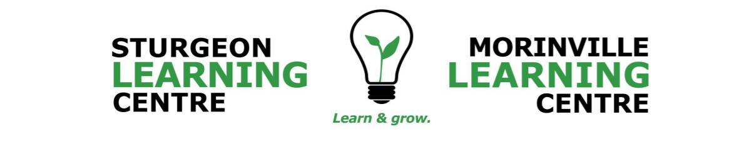

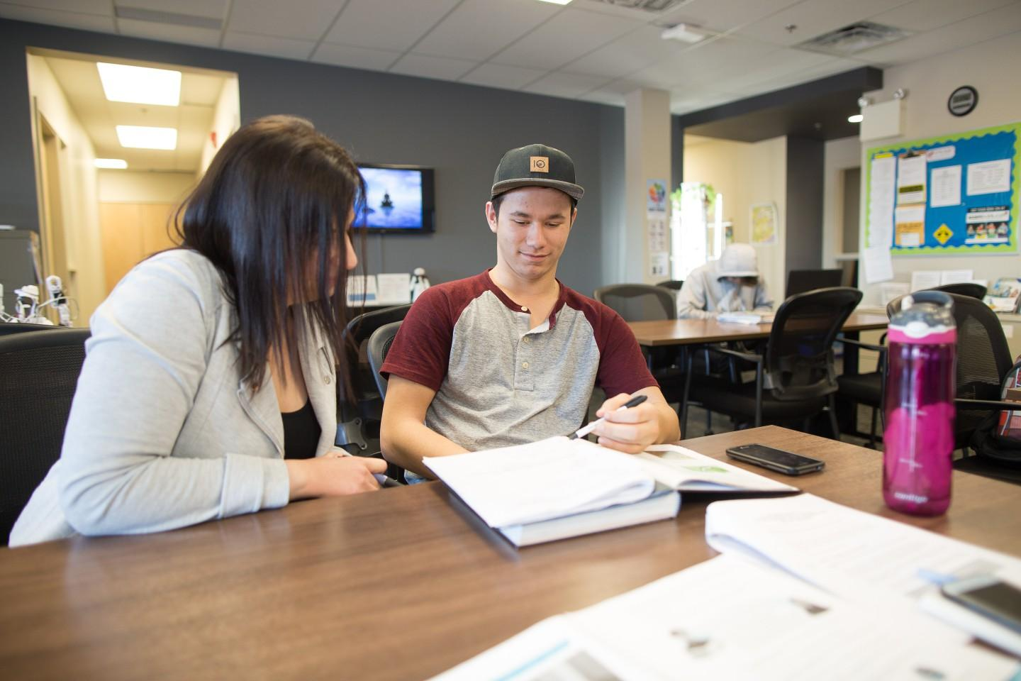

School Education Plan and
Annual Education Results Report

Combined 2021 Accountability Pillar Overall Summary MLC
Assurance Domain | Measure | Morinville Learning Centre |  |  | Alberta |  |  | Measure Evaluation
 |  | Current Result | Prev Year Result | Prev 3 Year Average | Current Result | Prev Year Result | Prev 3 Year Average | Achievement | Improvement | Overall
Student Growth and Achievement | Student Learning Engagement | 49.2 | n/a |  | 85.6 | n/a |  | n/a
 | Citizenship | 52.6 | 66.7 | 78.3 | 83.2 | 83.3 | 83.0
 | 3-year High School Completion | * | * | 15.6 | 83.4 | 80.3 | 79.6 | * | * | *
 | 5-year High School Completion | * | 18.6 | 29.9 | 86.2 | 85.3 | 84.8 | * | * | *
 | Diploma: Acceptable | n/a |  | 71.4 | n/a |  | 83.6 | n/a
 | Diploma: Excellence |  |  | 17.8 |  |  | 24.1
Teaching & Leading | Education Quality | 68.1 | 91.7 | 95.8 | 89.6 | 90.3 | 90.2
Learning Supports | Welcoming, Caring, Respectful and Safe Learning Environments (WCRSLE) | 62.5 | n/a |  | 87.8 | n/a
 | Access to Supports and Services | 59.4 |  |  | 82.6
Governance | Parental Involvement | n/a | n/a | n/a | 79.5 | 81.8 | 81.4

Notes: 1. Data values have been suppressed where the number of respondents/students is fewer than 6. Suppression is marked with an asterisk (*). 2. The 2020/21 administration of the AEA survey was a pilot. The Citizenship measure was adjusted to reflect the introduction of the new AEA survey measures. In addition, participation in the survey was impacted by the COVID-19 pandemic. Evaluations have not been calculated as 2020/21 survey results are not comparable with other years. 3. Participation in the 2019/20 Diploma Exams was impacted by the COVID-19 pandemic. In the absence of Diploma Exams, achievement level of diploma courses were determined solely by school-awarded marks. Caution should be used when interpreting high school completion rate results over time. 4. The “N/A” placeholder for the “Current Result” for PAT and Diploma Exam measures are included until results can be updated in the Fall. 5. Aggregated PAT results are based upon a weighted average of percent meeting standards (Acceptable, Excellence). The weights are the number of students enrolled in each course. Courses included: English Language Arts (Grades 6, 9, 9 KAE), Français (6e et 9e année), French Language Arts (6e et 9e année), Mathematics (Grades 6, 9, 9 KAE), Science (Grades 6, 9, 9 KAE), Social Studies (Grades 6, 9, 9 KAE). 6. Participation in the Provincial Achievement Tests and Diploma Examinations was impacted by the fires in 2016 and 2019, as well as by the COVID-19 pandemic in 2020. Caution should be used when interpreting trends over time. 7. Aggregated Diploma results are a weighted average of percent meeting standards (Acceptable, Excellence) on Diploma Examinations. The weights are the number of students writing the Diploma Examination for each course. Courses included: English Language Arts 30-1, English Language Arts 30-2, French Language Arts 30-1, Français 30-1, Mathematics 30-1, Mathematics 30-2, Chemistry 30, Physics 30, Biology 30, Science 30, Social Studies 30-1, Social Studies 30-2.

Combined 2021 Accountability Pillar Overall Summary SLC
Assurance Domain | Measure | Sturgeon Learning Centre |  |  | Alberta |  |  | Measure Evaluation
 |  | Current Result | Prev Year Result | Prev 3 Year Average | Current Result | Prev Year Result | Prev 3 Year Average | Achievement | Improvement | Overall
Student Growth and Achievement | Student Learning Engagement | 57.9 | n/a |  | 85.6 | n/a |  | n/a
 | Citizenship | 45.0 | 77.5 | 80.0 | 83.2 | 83.3 | 83.0
 | 3-year High School Completion | 18.6 | 30.0 | 30.0 | 83.4 | 80.3 | 79.6 | Very Low | Maintained | Concern
 | 5-year High School Completion | * | * | n/a | 86.2 | 85.3 | 84.8 | * | n/a | n/a
 | Diploma: Acceptable | n/a |  | 72.5 | n/a |  | 83.6 | n/a
 | Diploma: Excellence |  |  | 12.3 |  |  | 24.1
Teaching & Leading | Education Quality | 72.2 | 84.1 | 88.4 | 89.6 | 90.3 | 90.2
Learning Supports | Welcoming, Caring, Respectful and Safe Learning Environments (WCRSLE) | 68.3 | n/a |  | 87.8 | n/a
 | Access to Supports and Services | 83.3 |  |  | 82.6
Governance | Parental Involvement | n/a | n/a | n/a | 79.5 | 81.8 | 81.4
Notes:
1. Data values have been suppressed where the number of respondents/students is fewer than 6. Suppression is marked with an asterisk (*).
2. The 2020/21 administration of the AEA survey was a pilot. The Citizenship measure was adjusted to reflect the introduction of the new AEA survey measures. In addition, participation in the survey was impacted by the COVID-19 pandemic. Evaluations have not been calculated as 2020/21 survey results are not comparable with other years.
3. Participation in the 2019/20 Diploma Exams was impacted by the COVID-19 pandemic. In the absence of Diploma Exams, achievement level of diploma courses were determined solely by school-awarded marks. Caution should be used when interpreting high school completion rate results over time.
4. The “N/A” placeholder for the “Current Result” for PAT and Diploma Exam measures are included until results can be updated in the Fall.
5. Aggregated PAT results are based upon a weighted average of percent meeting standards (Acceptable, Excellence). The weights are the number of students enrolled in each course. Courses included: English Language Arts (Grades 6, 9, 9 KAE), Français (6e et 9e année), French Language Arts (6e et 9e année), Mathematics (Grades 6, 9, 9 KAE), Science (Grades 6, 9, 9 KAE), Social Studies (Grades 6, 9, 9 KAE). 6. Participation in the Provincial Achievement Tests and Diploma Examinations was impacted by the fires in 2016 and 2019, as well as by the COVID-19 pandemic in 2020. Caution should be used when interpreting trends over time.
7. Aggregated Diploma results are a weighted average of percent meeting standards (Acceptable, Excellence) on Diploma Examinations. The weights are the number of students writing the Diploma Examination for each course. Courses included: English Language Arts 30-1, English Language Arts 30-2, French Language Arts 30-1, Français 30-1, Mathematics 30-1, Mathematics 30-2, Chemistry 30, Physics 30, Biology 30, Science 30, Social Studies 30-1, Social Studies 30

Priority- Student Achievement
Assurance Domains and Student Achievement

Assurance in the education system occurs when community members, system stakeholders and education partners engage across five domains:

- Student Growth and Achievement;
- Teaching and Leading;
- Learning Supports;
- Governance; and,
- Local and Societal Context.

Student achievement is the priority for Sturgeon Public Schools. The domains of Teaching and Leading, Learning Supports and Governance support this priority and integrate local context to ensure students of Sturgeon Public Schools achieve.

Domains and Outcomes
Each domain is interconnected and part of a complete system supporting student achievement. Within each domain outcomes are identified to illustrate what will be happening consistently and strategies are outlined to describe how Sturgeon Public Schools will reach those outcomes. Measures are used and communicated to all stakeholders to illustrate success and inform the next cycle of improvement.

School Highlight or Context
The Morinville and Sturgeon Learning Centres are Outreach schools. The schools provide an alternative high school setting that offers an opportunity for students to earn high school credits using a flexible and individualized approach.
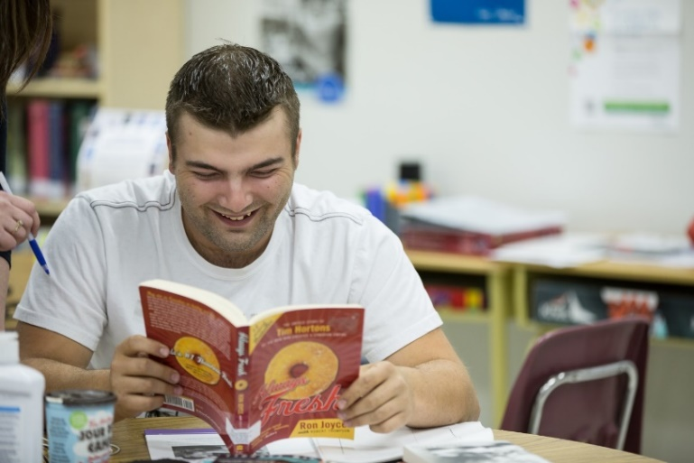
Many of the students enroll in one or two courses while concurrently attending Sturgeon Composite High School, while others attend on a full-time basis. Our school environment focuses on supportive teacher-learner relationships. We provide students the opportunity to learn at a pace that is appropriate for them. Students can take advantage of various learning methods including personalized face-to-face instruction as well as robust online learning environments.

Our teachers also provide feedback and support through personalized learning plans developed for specific student needs.
In addition to regular daytime hours, our teachers offer learning support late on Tuesday and Thursday evenings. This flexibility allows students to fit their education around a variety of responsibilities such as work, family, sport commitments, and other school programs.

Domain: Student Growth & Achievement
Assurance occurs:
Public assurance occurs when Sturgeon Public Schools’ students demonstrate strong achievement across provincial learning outcomes, engage critically, and continuously progress as learners.

SPS Outcomes
- Students achieve provincial learning outcomes and solve problems with real-world applications.

- Students use assessment feedback to identify strengths and areas of need and set learning goals.
Strategies
Division | School
- Teachers will co-create programming with parents, students and leadership to meet students’ individual needs in hands-on and active learning environments. | - Teachers are creating new, engaging online programming to better meet the needs of students as we transition away from traditional paper modules.  - Teachers are continually ‘evergreening’ courses to maintain engaging, relevant lessons to match the Alberta curriculum.
- Leaders will work with teachers to apply in-depth curriculum knowledge and support differentiated instruction in the classroom. | - Professional development is focused on how to program to best meet the mental health and educational needs of students.
- Teachers will communicate achievement of outcomes to students and families using division-identified tools. | - All students have access to coursework materials through Google Classrooms, and/or Hapara which can also facilitate parent access. Furthermore, detailed anecdotal records are maintained to ensure student engagement, connection, and transparent communication.

Local Measures – Morinville Learning Centre- Intellectual Engagement
Measures  Student Growth & Achievement |  |  |  | Results
Secondary 10-12 |  | 2018 | AB avg | 2019 | AB avg | 2020 | AB avg
Intellectual Engagement: Interest and Motivation
 |  | 60 | 43% | 60 | 43% | 33 % | 42%

Local Measures – Sturgeon Learning Centre- Intellectual Engagement
Measures |  |  |  | Results
Student Growth & Achievement |  | 2018 | AB avg | 2019 | AB avg | 2020 | AB avg
Secondary 10-12
Intellectual Engagement: Interest and Motivation |  | 21% | 43% | 53% | 43% | 17% | 42%

Analysis of Results
Last year’s strategies included the development and transition towards new digital learning tools such as Google Classroom. Furthermore, staff sprint goals targeted student engagement with their learning. Data was limited to a few responses but indicated that Interest and Motivation were low last year as compared to the Provincial average.
Opportunities for Growth
A broad survey will be created to all families, asking for suggestions on how to increase student interest and motivation to complete courses.
Promoting Virtual open houses at many of the institutions close to our communities (i.e., U of A, NAIT, and MacEwan University. By providing more information of what programs require for admission, will help motivate students to complete courses they have remaining.
Continue to develop Google Classroom and Hapara workspaces, while focusing on online instruction and learning will result in an increase in successful student completion. Working on ‘evergreening’ courses to improve current course content and add and develop courses will draw more students to the Learning Centres. Providing support to students and parents to help transition away from traditional paper-based module resources, will increase student engagement in their learning.

Domain: Teaching and Leading
Assurance occurs:
Public assurance occurs when Sturgeon Public Schools’ teachers and principals demonstrate all dimensions of the Teaching or Leadership Quality standards in a collaborative culture of learning.

SPS Outcomes
- Teachers and principals use a range of data and evidence to co-create student-specific learning activities to build achievement.
- Teachers and leaders attend to individual student learning and local school needs with skill and competence in leadership.
Strategies
Division | School
- Instructional leaders engage all stakeholders annually and use data to inform planning, student learning, and achieve success. | - All staff collaboratively analyze available data (Enrollments, Diploma registrations, Course Completion, and OurSchool.net survey results, to intentionally plan, improve teaching practice, and develop goals for the year.
- Staff participate in professional development and collaborate to address division and local goals. | - Staff meet monthly, as a group, to identify the needs of ‘students of concern’ and strategize on how we could work together to support individual needs.  - Staff are encouraged to attend PD related to their PGP goals related to Division Goals and/or the TQS  - Staff attend PD activities on Mental Health and other PD opportunities to help increase teacher skills in a variety of different areas.

Local Measures – Morinville Learning Centre- Quality Instruction
Measures |  |  |  | Results
Teaching and Leading |  | 2018 | AB avg | 2019 | AB avg | 2020 | AB avg
Secondary 10-12
Quality Instruction: Rigor | (out of 10) | 7.4 | n/a | 6.3 | 6.6 | 6.6 | 6.6

Local Measures – Sturgeon Learning Centre- Quality Instruction
Measures |  |  |  | Results
Teaching and Leading |  | 2018 | AB avg | 2019 | AB avg | 2020 | AB avg
Secondary 10-12
Quality Instruction: Rigor | (out of 10) | 6.8 | n/a | 6.7 | 6.6 | 7.0 | 6.6

Analysis of Results
Successes
Staff engaged with Sprint Goals, focusing on improvement to quality instruction. This approach saw teachers fine-tuning their pedagogy, highlighting areas of their practice that they identified as areas of opportunity.
Opportunities for Growth
The ability to collaborate with other outreach and distance learning centres will provide staff with valuable resources and tools to improve the quality of instruction. Successful instruction and quality learning experiences will be greatly benefited by the opportunity to collaborate with others in a similar role.

Professional Learning in 2021-2022
Division-Wide PD Days

Division-Wide professional development days provide the opportunity for all staff to collaborate and address division goals. All teachers and all Educational Assistants will be in attendance for these days.

Date | Location | Focus
August 30 | Virtual Delivery | Division Direction - Superintendent/CEO  First Nations Keynote, cohort and team learning sessions.  Universal Design for Learning – Subject and Grade Level focus.
March 14 | Virtual Delivery | First Nations Keynote, cohort and team learning sessions.  Curriculum meetings K to 6.
May 20 (pm) | Virtual Delivery  Or in Person if health regulations | AM - Planned by site Principals.  PM - Division Staff Appreciation

Site-Based PD Days

Site-based days provide the opportunity to continue division-initiated work with attention to local details and context. On Site-Based days, principals will ensure the principles of Universal Design for Learning are understood by all staff and used to inform practice.

August 27 | Focus: Visioning & Goals
Details | AM: Division PD Day - Kickoff / Keynote  PM: Staff start up- Introductions, tech needs, SPVA build, Expectations with parents/students
August 31- Operational- No Classes
September 20 | Focus: Mental Health & Wellness plan (both SPVA and Learning Centres)
Details | AM: Staff Meeting: PLC groups for new positions-affecting SPVA and LC.  PM: Kristin Lapierre- Will provide Mental Health & Wellness plan – both SPVA and LC staff
*October 12 | Focus: PLC groups throughout the division to help support grade specific needs Mental Literacy- How we can support students with these needs
Details | AM: All teachers from SPVA teachers: Split grade PD session with Adelee Penner  PM: SPVA joining LC team for PD with Adelee Penner- Mental Health Literacy; focusing on speaking the same language around mental health.
January 31 | Focus: To increase staff knowledge and ability to authentically infuse Indigenous perspectives, use of resources, and focus on curriculum connections  PLC groups- share and discuss technology
February 10 and 11 Teachers’ Convention – No classes
Details | AM: Workshop through ATA: ‘Finding our Way in Indigenous Education: Connecting Hearts & Minds. Focus is to learn resources and deepen understanding of Indigenous Focused Competencies in the new TQS.  PM: PLC group to discuss and demonstrate various technologies to help engage learners; work through assignments, assessment (i.e., KAMI, Screencastify, KAMI, Livescribe pen? Group Google classes re: similar course struggles; Hapara PLC).
April 19 | Focus: All day: Review IPP needs; anxiety supports
Details | All day: Review of students with IPP goals; Accommodations in place for final assessments? How can we better support IPP students?  Review and edit IPP’s as a group.
May 20 | Focus: All day: Mental Health- Increasing understanding of brain development and the impact on learning. Mental Health month- how can we provide info., workshops etc.?
Details | AM: Enrollment in Brain Story Certification as a class or Mental Health First Aid. Mental Health newsletter? Mental Health Day is in May; how can we share info with students/parents?  PM - Division Staff Appreciation Event
June 6 | Focus: Data comparison from Baseline in September
Details | Compare completion rates from last year as opposed to this year. What went well? How can we increase enrollments and more successful completions next year?
June 30- Operational- No Classes

Domain: Learning Supports
Assurance occurs:
Public assurance occurs when all students belong and learn in environments that support their needs. Public confidence is built when system resources are used to ensure optimum learning for all.

SPS Outcomes
- Public School Communities are safe, caring, respectful and inclusive.
- First Nations, Métis, and Inuit students achieve and succeed as part of a community committed to understanding foundational Indigenous perspectives and knowledge.
- Partnerships with external agencies are in place and used to enhance the conditions required for student achievement.
Strategies
Division | School
- Schools foster welcoming learning environments and implement supports for physical, social, mental, and emotional wellness in students. | - Student choice is a priority; students can connect in person, via Google Meet, phone call, or text. Our staff always support students where they are at, and where they are most comfortable.
- Schools provide diverse programming to ensure the success of all students in an inclusive learning environment. | - Nearly 40 different courses are offered to help students reach their goals! As best as possible, we offer anything necessary to help students learn and succeed.
- Schools implement and improve strategic plans to ensure understanding of Indigenous perspectives and knowledge. | - Staff will participate in Truth & Reconciliation Week to learn and embed Foundations Knowledge into lessons.  - Staff will participate in an Indigenous Focused Workshop facilitated by the ATA, January 2022.  - Staff will collaborate at staff meetings to help support each other in gaining knowledge and understanding of Indigenous peoples, so we can support student learning.
- Sturgeon Public Schools will ensure that partnerships are developed and maintained to support student health and wellness. | The Learning Centers have a counsellor that works directly with staff to help support students  - Staff will continue to support students and families that need supports, from our partner agencies.  - The Counsellor helps maintain connections with agencies that support student’s health and wellness information and helps facilitate connections with FCSS and families in need.  - Our counsellor also connects new families to Canada with the Mennonite centre on a case-by-case basis.  - The Learning Center also refers families to the Division Social worker when needed.

Local Measures – Morinville Learning Centre- Anxiety
Measures |  |  |  | Results
Learning Supports |  | 2018 | AB avg | 2019 | AB avg | 2020 | AB avg
Secondary 10-12
Emotional Health: Anxiety |  | 20% | 29% | 50% | 29% | 10% | 29%
School Context: Advocacy at School | (out of 10) | 6.9 | 2.6 | 3.9 | 2.6 | 3.8 | 2.6
Local Measures – Sturgeon Learning Centre- Anxiety
Measures |  |  |  | Results
Learning Supports |  | 2018 | AB avg | 2019 | AB avg | 2020 | AB avg
Secondary 10-12
Emotional Health: Anxiety |  | 38% | 29% | 33% | 29% | 50% | 29%
School Context: Advocacy at School | (out of 10) | 4.7 | 2.6 | 5.1 | 2.6 | 4.0 | 2.6

Analysis of Results
Successes
The supports in place last year are evidence in student reported advocacy at school. An environment has been created in which students feel comfortable and confident in advocating for their needs and finding success at school. A focus on relationships and personal connections are evident.
Opportunities for Growth
Mental Health concerns increased over the province last year. The Learning Centres will continue to advocate for students who have increased mental health needs by providing course-loads that meet the needs of students. The wide variety of programming options, and the focus on student choice in terms of instruction, will result in decreased anxiety in students. The opportunity provided to be educated in an alternative setting, the flexibility surrounding course selection, and the variety of ways for students to receive individualized assistance will mitigate stress and anxiety.

Domain: Governance
Assurance occurs:
Public assurance occurs when Sturgeon Public Schools’ engages openly with stakeholders with a focus on student achievement and demonstrates stewardship of system resources.

SPS Outcomes
- Students, families, staff, and community members are committed to a shared vision for student achievement.
- Resources are allocated and managed in the interests of ensuring student success.
Strategies
Division | School
- Division leadership in partnership with schools, plan and implement annual stakeholder engagement to assess progress and inform decision-making. | - Engaging staff, parents, and community leaders in a local survey.  - Principal will encourage families to attend local Council meetings to discuss ideas on how to continue to support students
- The Board of Trustees approves a budget aligned with division priorities and in accordance with all statutory, regulatory and disclosure requirements. | - Principals report school annual budget and update on progress to parents during the year.

Local Measures
From April 13 to April 20, 2021 566 participants shared 520 thoughts and gave 5,866 ratings on the thoughts of others answering this question: What are the most important things that Sturgeon Public Schools are doing or should consider doing to improve student achievement in our schools next year? Key thoughts that represent re-occurring themes aligned directly to Student Achievement and which affirm the current initiatives implemented within Sturgeon Public Schools. These included:
• Teaching students, the curriculum in different ways (differentiated instruction). It is important to have differentiated instruction, as it allows different types of learning styles/abilities.
• Connecting student achievement with enhanced experiences that are available at Sturgeon Public Schools. As a rural Public School Division with access to places like the Outdoor classroom, this should continue to be one of our most utilized assets for reimagined learning.
• Sturgeon Public Schools’ staff are recognized by our communities as caring staff who are dedicated to working with their students. Relationships with students, getting to know their strengths and areas of need, and knowing how to work with students at their needs is crucial.
Analysis of Results
Successes
Staff work collaboratively with parents and students to build and deliver individualized instruction to ensure student achievement. Students and parents can connect with teachers throughout the day.
Opportunities for Growth
A need for support systems was indicated. To help increase support for students, a new School Council will be created that will include all online program options available in Sturgeon School Division. These programs include the online Grade 5-9 Virtual Academy, the Shared Responsibility Program, the Parent Directed Home Education program, and both Learning Centers. This collaborative School Council will allow voice from the different programs that Sturgeon School Division offers.

Domain: Local and Societal Context
Assurance occurs:
Public assurance occurs when Sturgeon Public Schools responds proactively to local and societal contexts or concerns. Learning in Sturgeon Public Schools includes local context in educational programming.

SPS Outcomes
- Students demonstrate respect for themselves and others and show pride in their accomplishments and in their community.
- Students and staff model integrity and work ethic.
Strategies
Division | School
- Schools celebrate student and community achievement in local and division-wide events such as indigenous celebrations, athletic finals, STEAM, and CTS Skills competitions. | - Students are encouraged to participate in extracurriculars (as available) through the connections in their home communities and schools.  - The Learning Centers will promote and celebrate student and community achievement through newsletter communication, School Council, and social media.
- Schools implement student volunteer opportunities in their communities and encourage participation in division-wide events. | - Students and parents are welcome and encouraged to attend School Council meetings.  - Events happening around the division will be added to our websites and monthly newsletters to encourage students and families to participate.  - Students will be invited to monthly activities for both the SPVA and LC. These activities will be connected to curricular outcomes but will also foster a sense of community and belonging to the online schools.

School Partnerships
- Community based partnerships with student’s home school.
- Family Support Workers
- Referrals to outside agencies (counselling, addictions) as required.
- Indigenous Leadership within the Division
Local Measures
Local survey with Question: What are the most important things that Sturgeon Public Schools are doing or should consider doing to improve student achievement in our schools next year?
Analysis of Results
Successes
The success of the Learning Centres comes from meeting students where they are at and building on their foundation.
Students are met with a warm and welcoming atmosphere to help reduce anxiety and the stress of the traditional classroom environment. Staff work closely with Sturgeon Composite High School to offer the best programming and support for our students.
Survey results indicated an appreciation of the flexibility that is available to complete courses when students are able to work on them.
Opportunities for Growth
The Learning Centres continue to move courses online. They are focused on producing engaging lessons, updating course material, and updating assessments. The staff are moving away from traditional fill-in-the-blank and multiple-choice assessments to more comprehensive deeper understanding questions.
Survey results indicated a desire for more information for adult learners. Staff are discussing adding more information on available courses through our website. Results also indicated a desire for more courses. Staff are in the processing of developing K & E options for High School students seeking an Alberta High School Certificate of Completion.

